# Algorithm for file updates in Python

## Project description

This project uses python to read, modify, and write text files.

## Open the file that contains the allow list

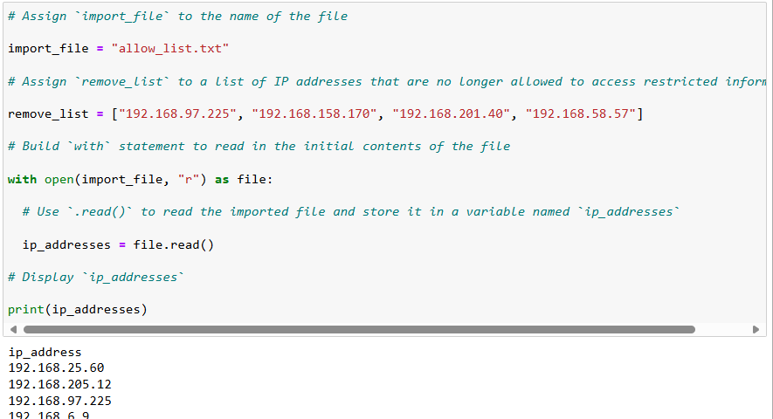

with open(import_file, “r”) as file: command is used to keep open the file while the commands below run.

## Read the file contents

Using file.read(), we can read the contents from a file

## Convert the string into a list

To convert a string into a list, we need to use ip_addresses.split()

This turns string into lists.

## Iterate through the remove list

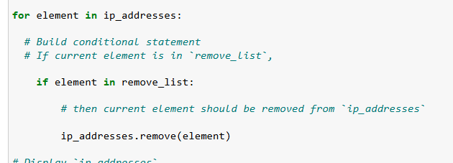

This for loop logic goes through every item in the list ip_addresses.

## Remove IP addresses that are on the remove list

If the element is included in remove_list, we then use .remove(element) to delete from the list.

## Update the file with the revised list of IP addresses

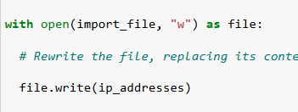

Updating the file with the updated list is simple, open the file again with “w” meaning it will open in write mode, then write the list into the file.

## Summary

This lab used open() command to make changes to the file of ip addresses. Using a python loop, it was possible to automate the removal process.